FLOREANT POS SETTUP

Contents

1 Introduction 1

2 Download and install Maven, Netbeans and Eclipse 1

3 Download code 2

3.1 Original code 2

3.2 My folder and zip code 2

4 Import the code 2

4.1 Maven 2

4.2 Eclipse 2

4.3 Netbeans 3

5 Fix the login function 4

6 Pre-build project by either Eclipse or Netbeans 5

7 Build project 5

7.1 Maven compiler 5

7.2 Eclipse 6

7.3 Netbeans 9

8 Run the database server 10

8.1 Directly from a file in the bin folder. 10

9 Run the app 10

9.1 Directly from a built file 10

9.2 Eclipse 11

9.3 Netbeans 11

10 Test the app 12

# Introduction

Firstly, I felt sorry for the first demo, but I definitely made it at that time as I reported to you. I tried everything from scratch again to give you the best instruction steps as I can. Please keep in touch so I can feed back you immediately. My tut is related to three different compilers: Maven Native compiler, Netbean and Eclipse compilers. This version require the minimum number of code lines to disable the password requirement.

# Download and install Maven, Netbeans and Eclipse

<https://netbeans.org/downloads/>  
<http://floreant.org/support/development>

# Download code

## Original code

**svn checkout svn://svn.code.sf.net/p/floreantpos/code/trunk floreantpos-code**

## My folder and zip code

After extracting folder.zip, you can get the floreantpos-code, this is a project folder; however, floreantpos-code.zip is a project zip. We can either import a project by a project folder or a project zip file.

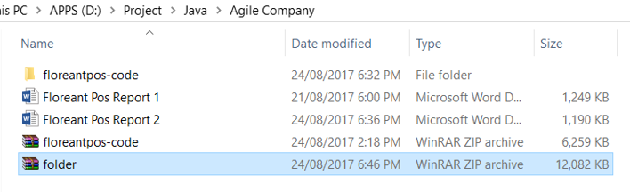

# Import the code

## Maven

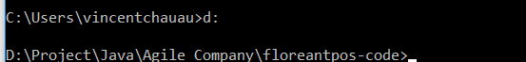

## Eclipse

Import from a project folder

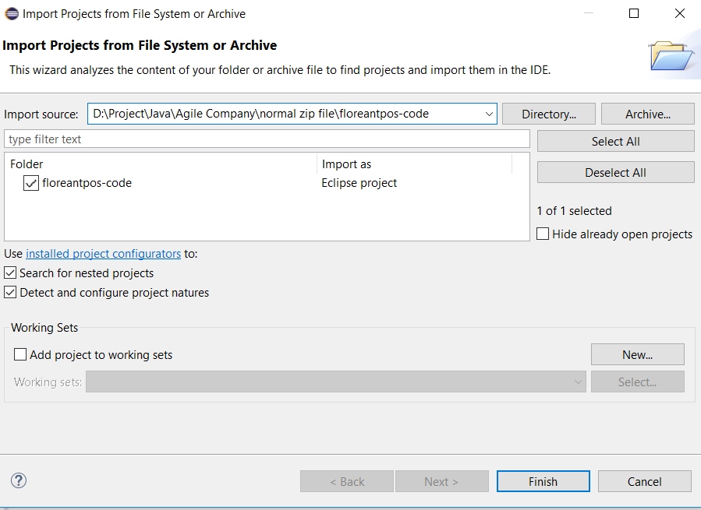

## Netbeans

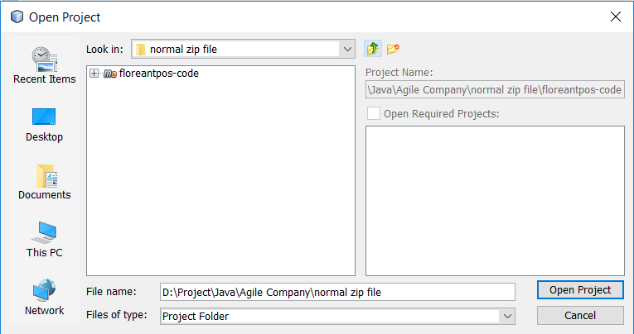

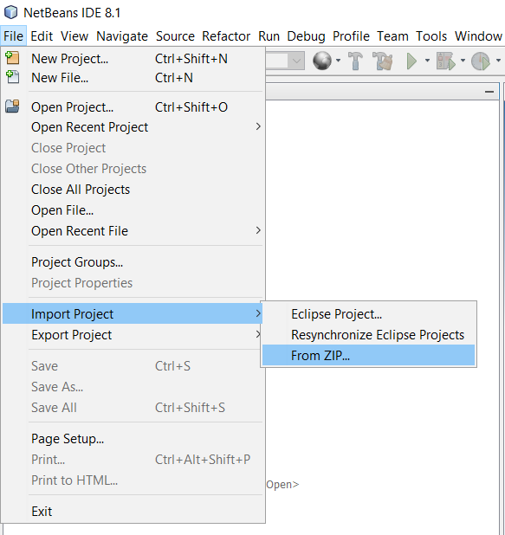

# Fix the login function

Step 1: Search “PasswordEntryDiaglog” to find out all results relating to require a password. There are two functions: getUser to require username, show to require password.

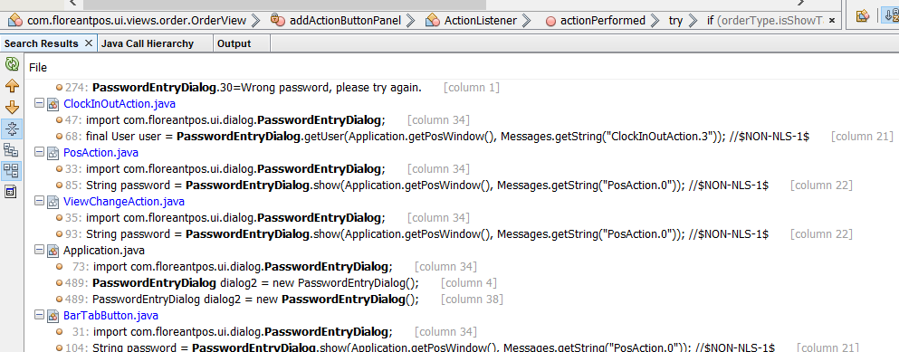

Step 2: Change these functions to the default password “1111” and default user “Administrator”. The original code are commented.

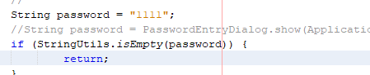

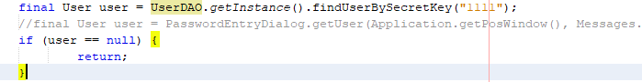

# Pre-build project by either Eclipse or Netbeans

Step 1: If these folders have been created by Maven compiler, they have to be deleted before we build the project with either Netbeans or Eclipse. Netbean and Eclipse will automatically download them again.

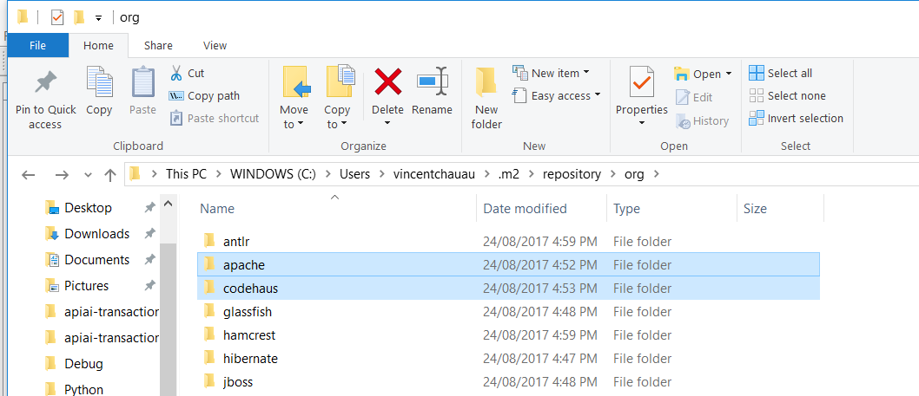

Step 2: Set up the bundle resource files. These two files needs to be copied to three different folder before building by Netbeans which is a bit different from Maven

  
\floreantpos-code\i18n\  
\floreantpos-code\src\

# Build project

## Maven compiler

mvn clean

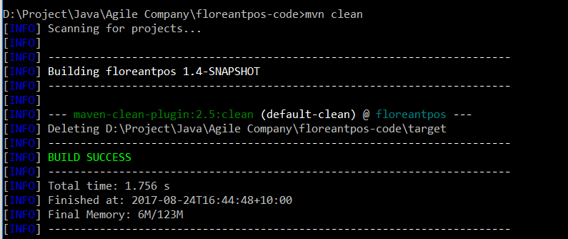  
mvn package

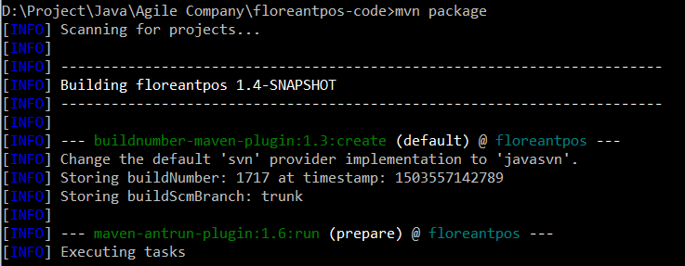

## Eclipse

Update Maven project in Eclipse then build or build with dependencies in Netbeans

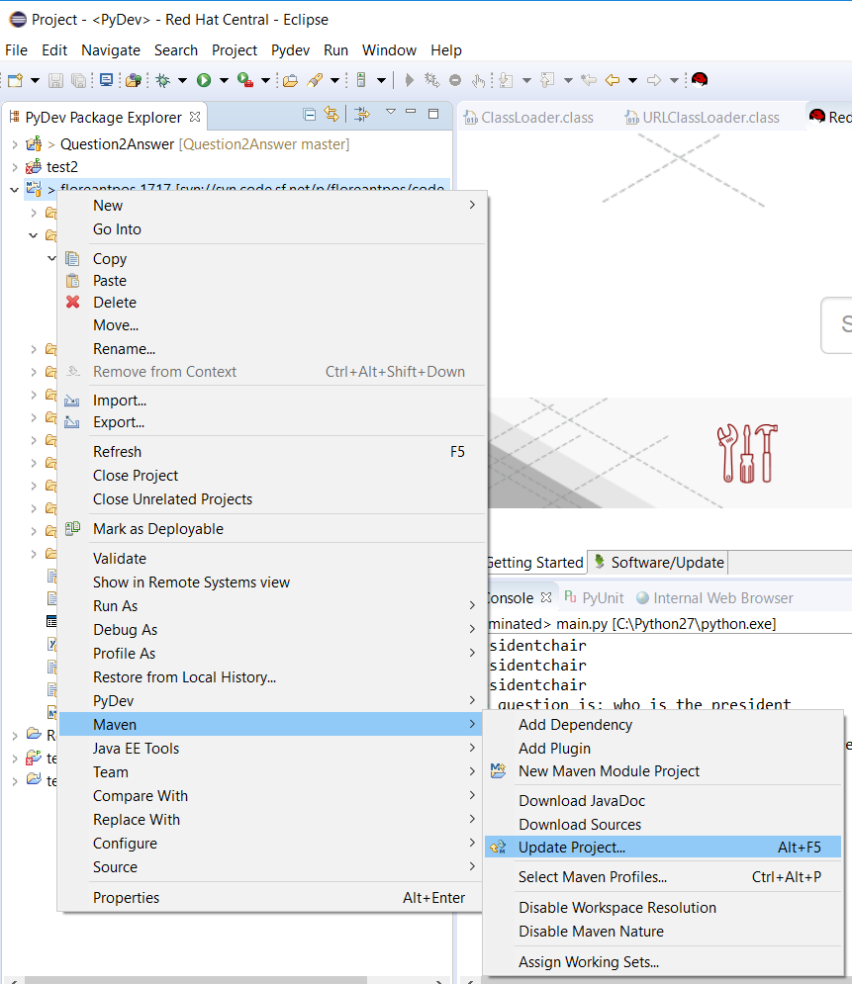

Maven clean => maven install => maven build

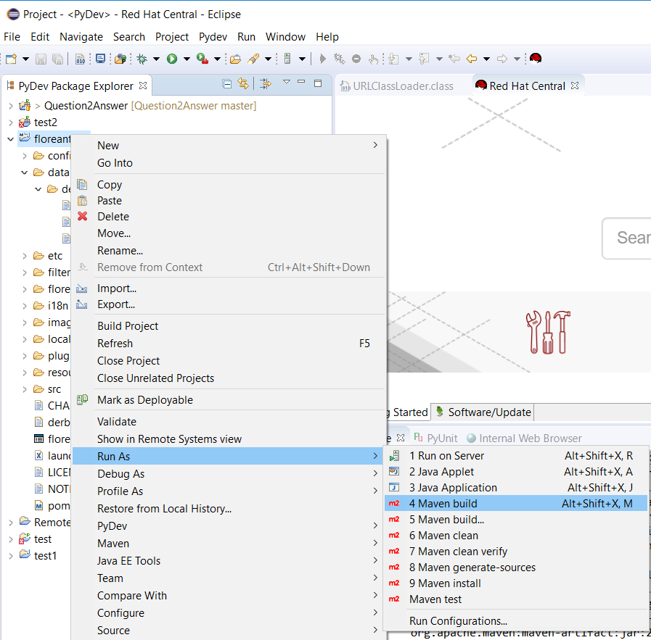

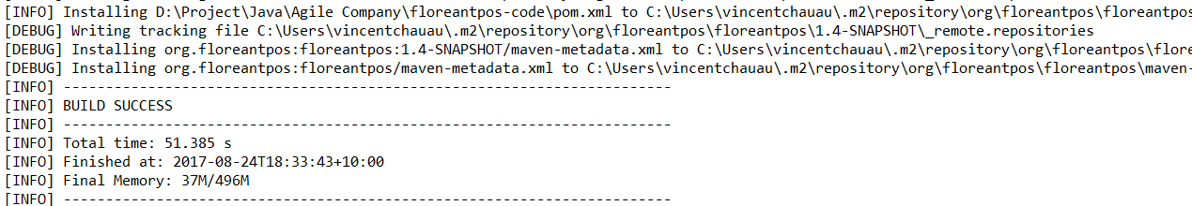

## Netbeans

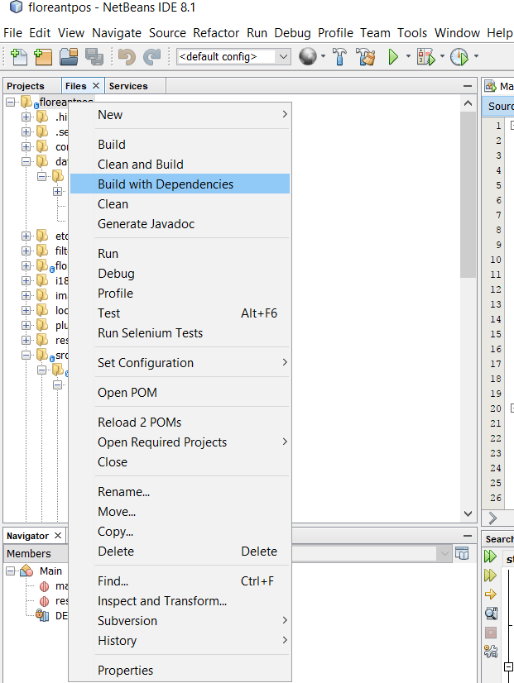

# Run the database server

## Directly from a file in the bin folder.

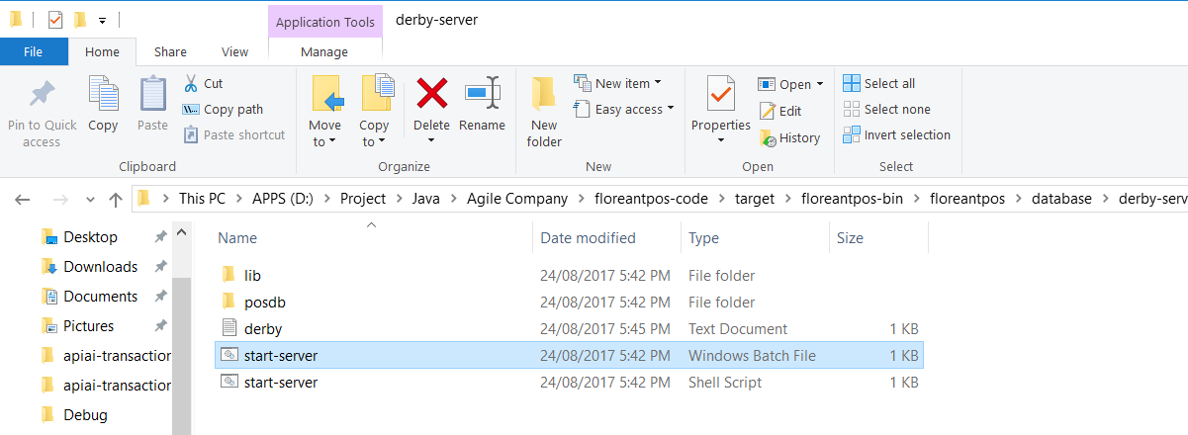

# Run the app

## Directly from a built file

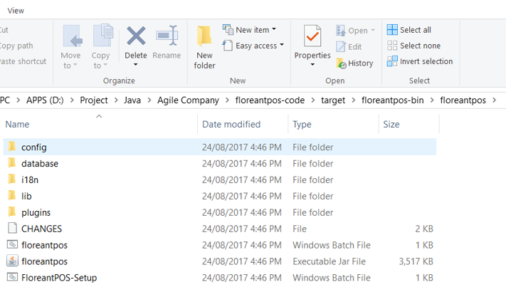

## Eclipse

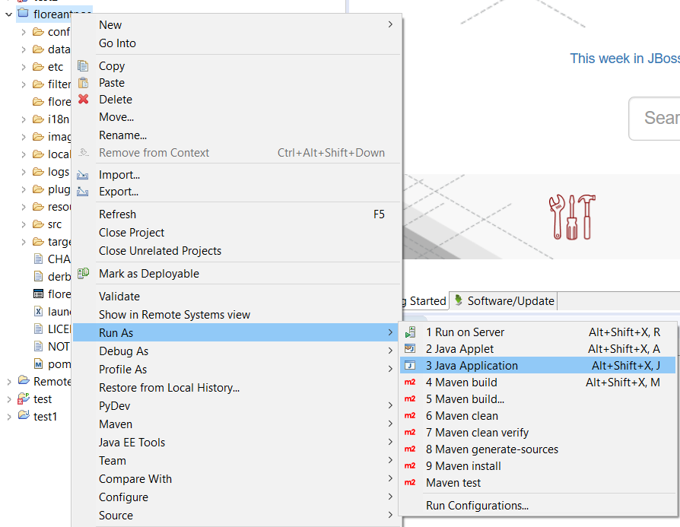

## Netbeans

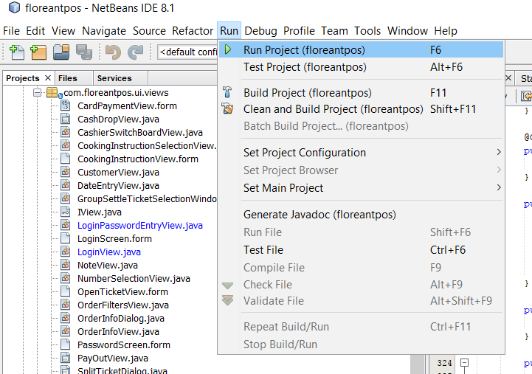

# Test the app

